Accounts Payable for End of Year

After discussions with multiple auditors, one of the areas they felt needed further explanation was in the way we should handle Accounts Payable for goods and/or services ordered and received by August 31, but no invoice has been received by the time we are ready to close our books for the current fiscal year. Once you have completed the EOY close, these payments should be recorded in the prior file ID as a payable, charging the expense to the correct expenditure account and allowing TxEIS to post to the appropriate liability account. This ensures the expenses are shown in the correct fiscal year. However, at this point in the process, we no longer want to actually print checks in the prior file ID. We will print the checks in the Current File ID, paying from the liability account. Your step-by-step is shown here:

_____1. Update Contra Account in file ID 0. From Tables > District Finance Options, Change the Payable Account from 2110.00 to 2110.01
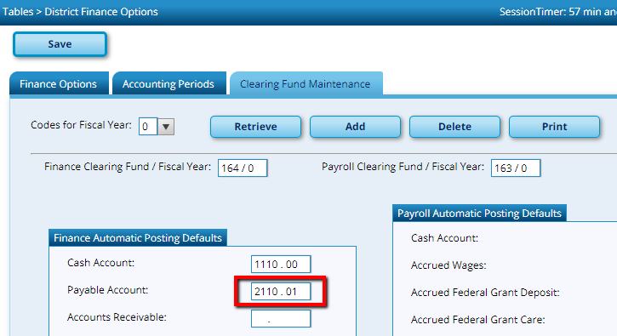
_____2. Enter Payment Authorizations or Purchase Orders in file ID 0, but DO NOT process for payment. File ID 0 > Maintenance > Postings > Check Processing- PA or PO. Code to the appropriate expenditure account(s) and Save. If you scroll to the right, notice the Contra Account has changed to the new Payable Account that you entered in step 1. After saving, this debits the expense account and credits the liability account (Contra Account). Note the PA number upon saving. It is a good practice to reference this number when you actually print the check in File ID C.
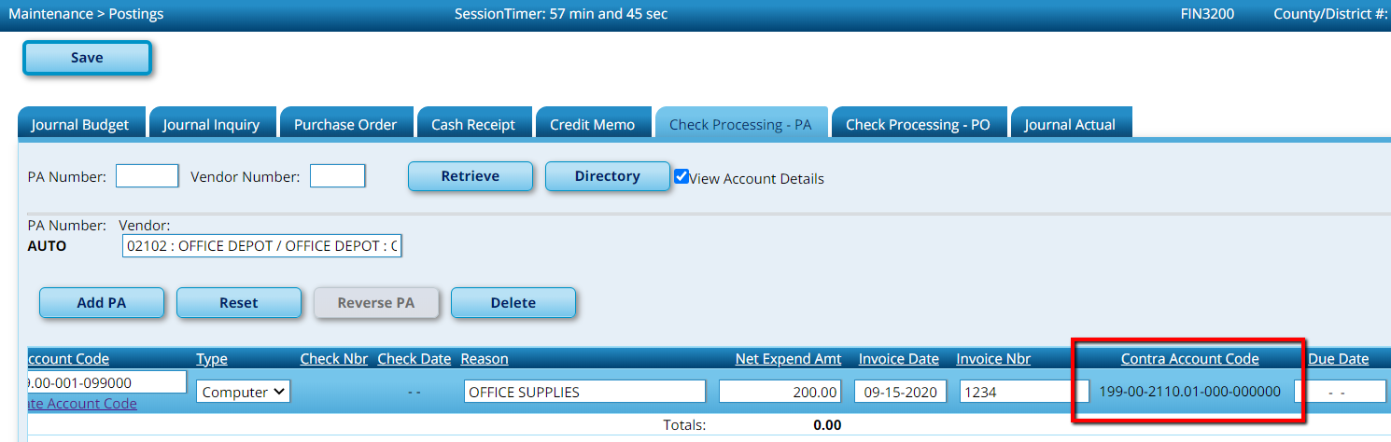

_____3. Enter Payment Authorizations in file ID C. File ID C > Maintenance > Postings > Check Processing- PA or PO. In the current file ID, you will want to code the payment to the liability account that you used in File ID 0. In step 1, we used 2110.01 so we would code the expense to 199-00-2110-01, 240-00-2110-01, etc. depending on what fund the invoice is being paid out of. Save. Remember in step 2, you posted a credit to the liability account in file ID 0, so now you are posting the expense to the liability account so it will zero out when you roll balances to file ID C (or receive opening entries from your auditor).

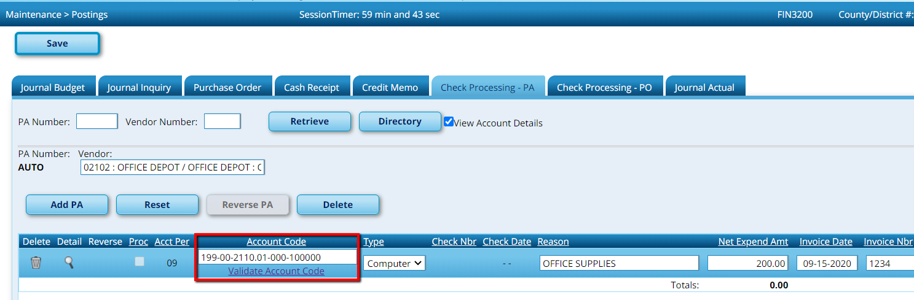

_____3. Print checks in file ID C. File ID C > Maintenance > Check Processing.

_____4. Reconcile the Payable Accounts in file ID 0 and file ID C. Run a General Ledger Inquiry out of current year, and compare it to an unpaid check payments list in File ID 0. They should match.

File ID C > Inquiry > General Ledger Inquiry. Enter 2110.01 in the object and sub-object fields.
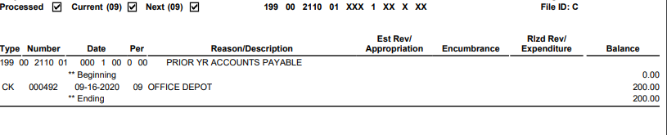
File ID 0 > Reports > Journals, Checks, Detail Ledgers > Fin1300 Check Payments List. Choose to view unpaid checks in the parameters
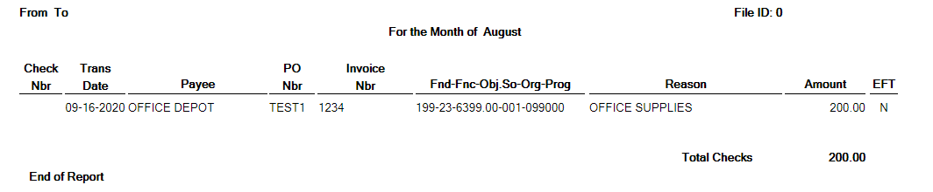
Note: It is important that you add all transactions in File ID 0 BEFORE you send your file to your auditor. If you enter another check that should be charged to expenses in File ID 0 after giving the file to your auditor, contact them immediately.

